Q:6:

Created a simple ansible playbook:

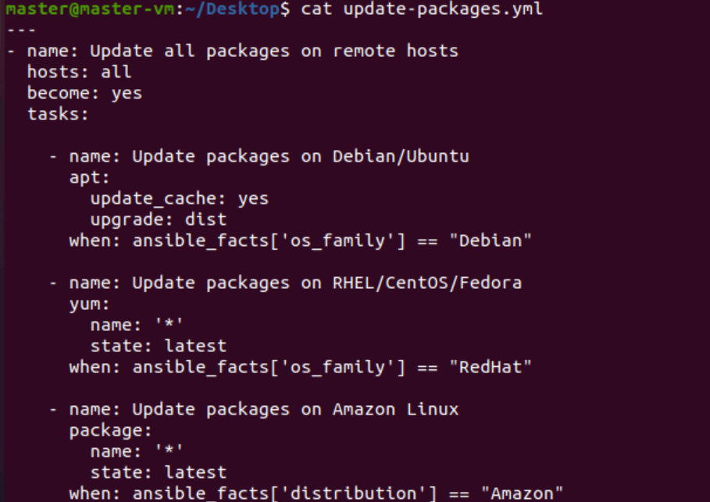

And I runned the playbook:

